CAPE COAST METROPOLITAN ASSEMBLY
(CCMA)
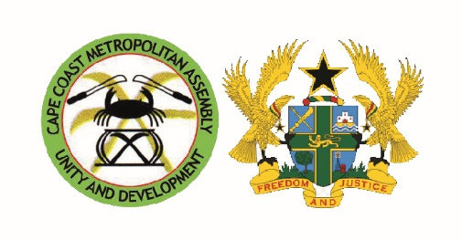

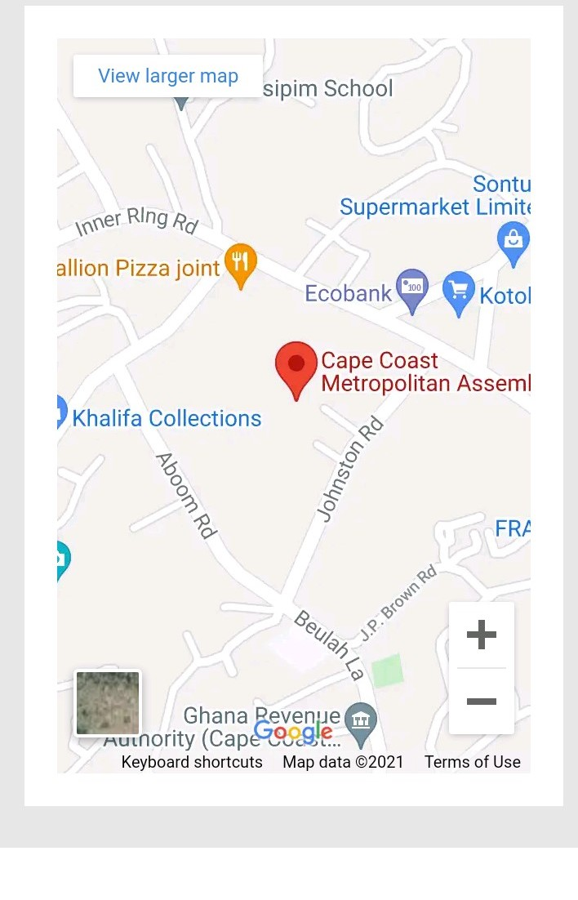
OUR ADDRESS
CAPE COAST METROPOLITAN ASSEMBLY
P. O. BOX 200
CAPE COAST

EMAIL: info@ccma.gov.gh
Facebook: Cape Coast Metropolitan Assembly/Facebook.com
Tel: 0312-291355
Web: http://www.ccma.gov.gh
Fax: 0332-132226
Digital Address: CC-000-5015

SERVICE CHARTER

1.0 INTRODUCTION
Cape coast metropolis is the only Metropolis out of the twenty-three (23) districts in the Central Region. Cape coast metropolis lies within latitudes 5. 20’ and latitudes 1. 11’ to 1.41’ west of the Greenwich meridian. Cape coast is divided into two administrative Sub-Metropolitan Districts, i.e. Cape Coast North and South (which are also the constituencies).
1.1 VISION
To create and maintain a smart, sustainable, resilient city
1.2 MISSION
To improvement the quality of life of the people living within the city of Cape coast by providing leadership and opportunities for social and economic development whilst maintaining a clean and secured environment.
1.3 CORE VALUES
- Innovation
- Teamwork
- Proactive
- Integrity
- Discipline
- Quality Service
- Excellence
- Sustainability

1.4 FUNCTIONS
(a) Be responsible for the overall development of the Metropolis.
(b) Formulate and Execute Plans, Programmes and strategies for effective mobilization of the resources necessary for the overall development of the District.
(c) Promote and support productive activities and social development in the Metropolis and remove any obstacle of initiative and development.
(d) sponsor education of students from the Metropolis to fill particular man power needs of the Metropolis especially in the social sectors of education and health, making sure that the sponsorship is fairly and equitably balanced between male and female students.
(e) Be responsible for the development, improvement and management of human settlement and the environment in the Metropolis

(f) In collaboration with the appropriate National and Local Security agencies, be responsible for the maintenance of security and public safety in the Metropolis
(g) Ensure ready access to courts in the Metropolis for the promotion of justice.
(h) Initiate, sponsor or carry out such study as may be necessary for the discharge of any of the functions conferred by the Act or any the enactment, and
- Perform such other functions as may be provide under any other enactment.

2.0 OTHER COLLABORATIVE AGENCIES
- Information Service Department
- National Commission on Civic Education
- Ghana Police Service
- National Intelligence Bureau
- National Health Insurance Authority
- Electoral Commission
- Youth Employment Authority
- NADMO
- Centre for National Culture
- Non-Formal Education
- Ghana Fire Service
- Audit Service
- Ghana Immigration Service
- Commission on Human Rights and Administrative Justice
- Ghana Electricity Company
- Ghana Water Company;

3.0 WHAT WE EXPECT FROM THE PUBLIC
The Assembly expects full co-operation and compliance with its rules, regulations and procedures to ensure smooth service delivery.
- The public will participate in the various community level education programmed on sanitation, hygiene, revenue collection and others
- The bye-laws of the Assembly will be complied with to ensure effective administration of the District.

4.0 WE ARE RESPONSIBLE FOR
- Issuance of Building Permit
- Birth and Death Registration
- Issuance of Outdoor Advertisement
- Registration of Marriages
- Issuance of Business Operating Permit
- Development Control – Orderly Physical Development of Settlements
- Waste Management
- Revenue Mobilization
- Fixing of Rates
- Disaster Management and Prevention
- Provision of Basic Socio-economic Infrastructure including Schools, Markets, Lorry Stations, Public Toilets and Roads
- Maintenance of Peace and Security
- Facilitating Local Economic Development
- Tourism Development
- Issuance of Food Handler’s Certificate
- Business Advisory

5.0 SERVICE STANDARDS
We provide the following services regularly with utmost concern for our clients’ satisfaction
SERVICE | TIME FRAME | RESPONSIBLE DEPARTMENT / UNIT
Issuance of Building Permit | Within 30 Working Days | Works Department / Physical Planning Department /Spatial Planning
Preparation and Approval of Planning Scheme/Layout | Within 30 Working Days | Physical Planning Department/Spatial Planning
Issuance of Outdoor Advertisement | Within 30 Working Days | Works Department
Issuance of Business Operating Permit |  | Budget and Rating/Finance Department
Registration of Marriages | Within 21 days | Legal department
Issuance of food Vendor Certificate | Within 5 Working Days | Environmental Health and Sanitation Unit
Exhumation, Pauper and Mass Burial |  | Environmental Health and Sanitation Unit
Public Education on Hygiene | periodically | Environmental Health and Sanitation Unit
Business Advice |  | Visit our Business Advisory Centre (BAC) any working Day

6.0 PROCEDURE FOR ACQUIRING DEVELOPMENT OR BUILDING PERMIT
WHO SHOULD APPLY
Any person or organisation that wants to put up a building, transform an existing building, demolish an existing building.
PROCESS
- Submit full set of applications to the Physical Planning Department
- Attach completed land ownership document from Lands Commission
- Attach Four (4) copies of structural drawings signed by an Engineer
- Technical Committee will vet all applications
- Successful Applicants will be formally contacted after the meeting of the Spatial Planning Committee
- Likewise, unsuccessful applicants would be formally informed and taken through the process again.
The above process takes Twelve (12) weeks for complete processing.

7.0 REQUIREMENT FOR MARRIAGE REGISTRATION
For legal registration, couples are mandated to file a 21 days’ notice of marriage for publication. The following details of the couple will be required
- Name of Prospective Spouse
- Marriage Status i.e. whether any of the couples had been married before
- Types of Marriages i.e. either Customary, Muhammedans or CAP 127 Ordinance Marriage
- Occupation
- Age
- Location and Duration of Stay
Each couple must endeavour to present one of the following valid National ID cards
- National Identification Card
- Voters ID Card
- Driver’s License
- Passport
NB:
Prospective couples should at least live in the District for Six (6) months before they can get married. Also, for marriage status, if you are a widow or widower, a copy of death certificate of your deceased spouse will be needed

8.0 BIRTH AND DEATH REGISTRATION
The Birth and Death Registry exists to provide Accurate, Reliable and Essential Information on all births and deaths occurring in the country for Socio-Economic Development and Planning of the country through their registration and certification.
Procedure for Birth Registration (0-12 months)
- One-on-one interaction between the child’s parent and registration officer
- Officer requests for Childs’s primary birth record (weighing card/ baptismal certificate)
- Officer completes a Birth Registration Form (Form A)
- Officer enters child’s birth record into the Register of Births
- Officer issues Birth Certificate (Form R) to the child’s parent instantly

Death Registration
- One-on-one interaction between the deceased’s relative and the Registration Officer
- Officer requests for deceased’s primary death record (Medical certificate of cause of death / Coroner’s report)
- Officer completes a Death Registration Form (Form B)
- Officer enters deceased’s death record into the Register of Deaths
- Officer issues Burial Permit /Death Certificate to the deceased relative instantly
Duration of Issuance of Certified Copy of Death: 10 working days

9.0 ISSUANCE OF MEDICAL / HEALTH CERTIFICATE FOR FOOD / BEVERAGE VENDORS
Those affected include Food Processing Companies, Hotels, Catering and Restaurant Staff, Food / Beverage Vendors
Procedure:
- The Environmental Health Unit declares a Mass Registration and laboratory test for food vendors in the District
- Vendor completes a registration form
- A mass laboratory test is organised for vendors at an Accredited Laboratory Centre
- Upon receipt of the laboratory results, a Health Certificate is then issued to vendors who are declared medically fit.

10.0 THE BUSINESS ADVISORY CENTRE (BAC)
The Business Advisory Centre focuses on Micro, Small and Medium Enterprise (MSMEs) access to high quality, affordable and accessible business support services through the provision of a Client-Focused quality programme. The Centre also offer advisory and counselling services and also empower MSMEs (i.e. CBOs, FBOs / LBAs) for sustainable development

Benefits of Registering with the BAC
- Introduce MSMEs to banks
- Business Management Skills
- Business Planning
- Entrepreneurship
- Marketing
- Investment Financing
- Banking Culture / Credit Management
- Networking
- Formation of FBOs /LBAs
- Strengthening of FBOs /LBAs
- Sustaining FBOs / LBAs
- Group Dynamics
- Palm oil Processing
- Palm Kernel Oil Processing
- Cassava Processing
- Soap Making
- Cosmetic / Bleach Production
- Meat Processing
- Spice Processing etc.

11.0 INFORMATION, TRANSPARENCY AND CONVENIENCE
- Notice Boards have been made available at our main office and Sub-Metro offices
The Cape Coast Metro Assembly provides its clients with all the necessary information they need to access our services
- Information are also made available at revenue points throughout the Metropolis
- We are developing websites and other social media platforms from which the public can source for information.

12.0 WE STRIVE FOR:
- Continuous development in our service delivery
- The creation of an enabling environment for socio-economic development
- Empowerment of women and other vulnerable groups to participate in governance and the Assembly’s Development Agenda
- The protection and promotion of public health and the prevention of diseases
- Provision of information in an open and transparent manner
- Creation of a conducive environment for Public Private Partnership (PPP) in our service delivery to ensure Efficiency and Effectiveness
- Compilation of a comprehensive Socio-economic database that will be accessible to the public

13.0 COURTESY AND COOPERATION
- All office doors are marked to facilitate easy identification
- Friendly client service officers will be on hand to provide various services
- Assembly staff with clear identification are also available to provide information and other support services
- A well trained development control task force will visit various construction sites to ensure adherence to building regulations
- Developers are entreated to provide valid development permit
- Courteous revenue collectors will go round daily to collect various rates
- Rate payers are entreated to pay approved sums and collect receipts covering amounts paid.
14.0 COMPOSITION OF ELECTORAL AREAS
Sub-metro | zone | COMMUNITIES
Cape Coast North | Abakam Ola University | Kwaprow, kwesipra  Kokwaado  Apewosika  Akotokyir  Duakor  Abakam  Ahenboboe  University Old Site  University New Site  Ola Madina  Low cost  North Ola  Black start(MoH)  Augusco bungalows  SSNIT Flats
 | Efutu-kakomdo-Mpeasem | Efutu,  Efutu Ekutuase  Efutu Seguase  Efutu Mampong  Koforidua  Ewusikrom  Efuttu kowaado  Ansapetu  Nkokosa, Fadur  Ankaful,Camp  Nanabakrom,Taedo  Esuekyir,  Esuekyir Estates  Esuekyir comm.1  Amoyaw,Nyinasin  Kakomdo,Amisano  Ebubonko,C-poly  Dehia,kramotawia  Mpeasem, Brabedze  Kayefi,Senewin  Ewusukrom,Dankwaakrom  Nyeku,Besakrom  Akweikrom,Akaikrom  Kyirakomfo,Wenyi Ato  Brimso,Akwakrom  Pomanye, Kuease,  Nyamebekyere Zongo  Asenadze, Ekoo, Dunkor.
 | Abura-Adisadel-Pedu | 1st Ridge,2nd Ridge,3rd Ridge 4th Ridge, Nkanfoa, Nkanfoa Nkanadze, Nkanfoa Beseadze, Abura Etsifi, Abotar yie, Adeebi krom, The boy, Tanokrom, Roman Hill Ba Akwar, Nkwantado, Assim Aba Anwanakrom,Eyifua Estates, Abura Estates, Mintsiminim (Nurses’’ Flat)  Pedu, Adaaso, Pedu Junction, Ngnabado, Abakaadze, Buwano, (Police Flats) Hqrs,  Ntwemakrom,Adisadel Village, Zongo, Adisadel College,Staff QuartersEstates,Tsibu Darko,West Adisadel, Tankofedo.
Cape Coast South | Akyim-Amanful-Brofoyedur_ Ekon | Amanful, Guamu  Amanful Etsifi  Paaksedo, Tsiafiekyir, Amoakofua, Brofoyedur, Ekon  Green hill, Ghana National, Cape Deaf,Aggrey Memorial bungalows, Akyim(Holy Child), Menyamenwu,Nkwantado, Savoy, Last Mobil.
 | Gyegyem-Ntsin-Krootown | Ayiko- ayiko,Ashanti Road, Mensah Sarbah, Enyitsewdo, Ewim, Gyegyem, Social welfare, Gyegyeano, Idan,Ntsin, Krootown London Bridge Tantri,Anaafo,Emissaekyir, Bentsir
 | Anakyen-Bakaano_  Chapel Square | Anakyin Bakaano, Gyankorbir, Chapel Square, Victoria park, Awendadze, (abease) Nkum, Fawohodzi, Kawaanopado,Abowinmu, Kotokuraba, Kotokuraba Zongo, Coronation, Ntotoo, Turom,Katse kwaado (DawsonHil)l Taamesease,Acquarium Down, Brickfield.
 | Aboom,Esikafoambantem,Kadadwen | Aboom,Aboom wells,  Acquarium,Antem,  Esikafoambantem,  kadadwen,Master Sam,  Tsintsimhwe,Siwdo compound,  Siwdu Village,  SiwdoEstate,  Buwano.

